Daniel Dovale

4/22/2024

Aqueduct Write-Up

The aqueduct problem involves directing water through a grid-based system, from a source to several bathhouses. Given an m x n grid of stations with varying heights, each connected by ramps, the time it takes to move between stations is calculated based on height differences. The goal is to find the minimum cost of a supply path that starts at a source station, visits all specified bathhouses, and ends at any one of them. The solution is designed with a combination of graph construction, the Bellman-Ford algorithm, and a recursive function with memoization to determine the optimal path.

The **‘build_graph’** function constructs a graph where nodes represent stations and edges represent ramps with weights based on height differences. The Bellman-Ford algorithm is used to find the shortest paths from the source station to all other stations in the graph, providing distances needed to determine the minimum cost of visiting all bathhouses. The recursive function **opt** takes two parameters: a starting station **s** and a set **B** of bathhouses to visit. It computes the minimum cost to traverse the path by recursively exploring all possible routes, memoizing intermediate results to avoid redundant calculations. The recursive equation for **opt** is:

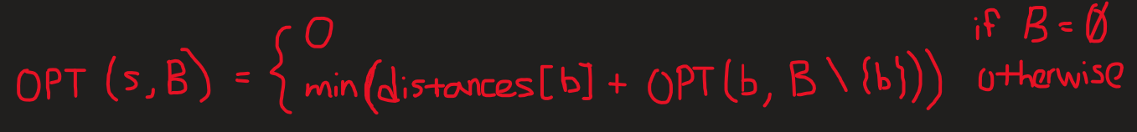

This recursive approach explores different paths by varying the order in which bathhouses are visited, with memoization to store intermediate results and avoid recalculating the same values. The use of the Bellman-Ford algorithm ensures an efficient and effective solution, allowing the recursive function to find the optimal path with minimal complexity. The final output, representing the minimum cost to visit all bathhouses, is saved in **‘pathLength.txt’**, providing the required result for the problem.